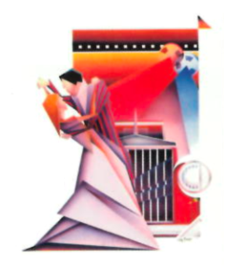
NORM WOODEL
ACTOR/Voice - Television - Stage - Film
SAG/AFTRA

TELEVISION PORTRAYAL DIRECTOR
Chicago PD Landlord Nicole Rubio
Matlock Sex Addict Celebrity DJ Christopher Hibler
The Untouchables Tuff Mob Boss John McPherson
Dottie West Story Music Legend-Jim Reeves Bill D’elia
Turks Fist Fighting Cop Phil Sgricca
Early Edition Various Blue-Collar Guys Stephen Cragg
Elvis 1950s Anti-Elvis DJ ABC-Various
Ernest Green Story Racist Newspaper Reporter Eric Launeville
Proud Heart Gentle Country Lawyer Jack Cole
FILM
The Client First TV Reporter Joel Schumacher
Radioland Murders 1940s Radio Reporter Mel Smith - G Lucas
The Expert Death Row Inmate William Lustig
Sodium Death Kiss Zombie Hunter Kerry Shaw Brown
Assassination 1800s CH Police Chief David Schmudde
Post Mortem Fumbling Detective Keith Estrada
The Ghastly Saga Irish Con-Man Kerry Shaw Brown
MUSIC VIDEO ROLE SONG TITLE
Dolly Parton Caddy Salesman “Why’d Ya Come In Here”
Reba McEntire Gabby Cabbie “Fancy”
STAGE CHARACTER THEATRE COMPANY
*Golden Boy Mr Bonaparte Griffin Theatre
The Magic Play Father Goodman
Outside Mullingar Tony Reilly Buffalo Theatre
Festin Heilge Steep Theatre
Cat On Hot Tin Roof Big Daddy Buffalo Theatre
Fucking Men-by Joe DiPietro Donald Bailiwick Theatre
The Best Man Senator Carlin Remy Bumppo
LIFE EXPERIENCE: *Jeff Award - Best Supporting Actor, Emmy Winning Producer, TV Journalist/Anchor, DJ, Marketing Executive, Top National Voice Over Talent, Military, natural in any bar, Best Dancer Class of ’68.

AGENT:StewartTalent.com normwoodel.com

